Output link(chrome):
file:///C:/Users/Sahithya/OneDrive/Desktop/New%20folder/index.html

Output link(edge):
http://127.0.0.1:5500/
To Open this link
Open Chrome or Edge and copy respective link and paste to interact with the webpage ( Edu Quest Educational Dashboard )

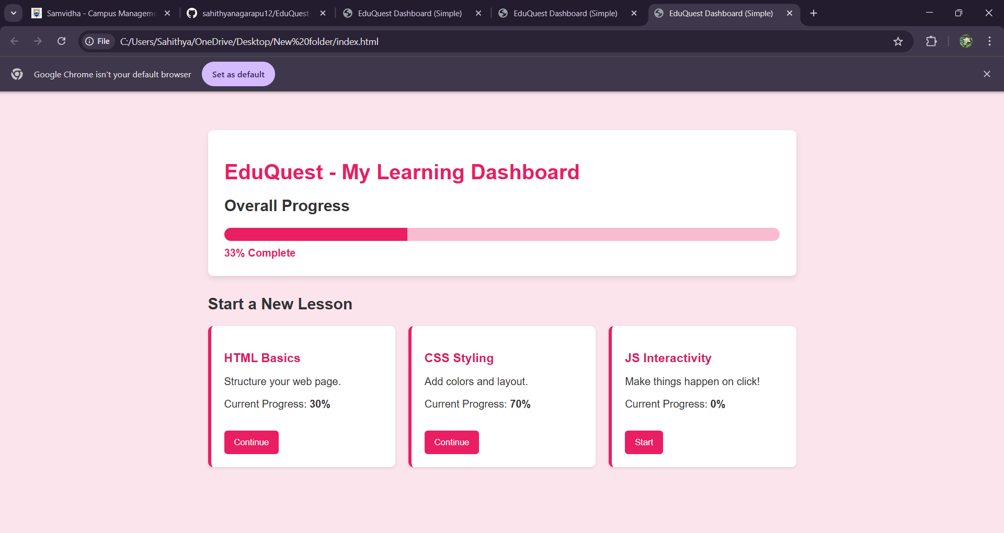
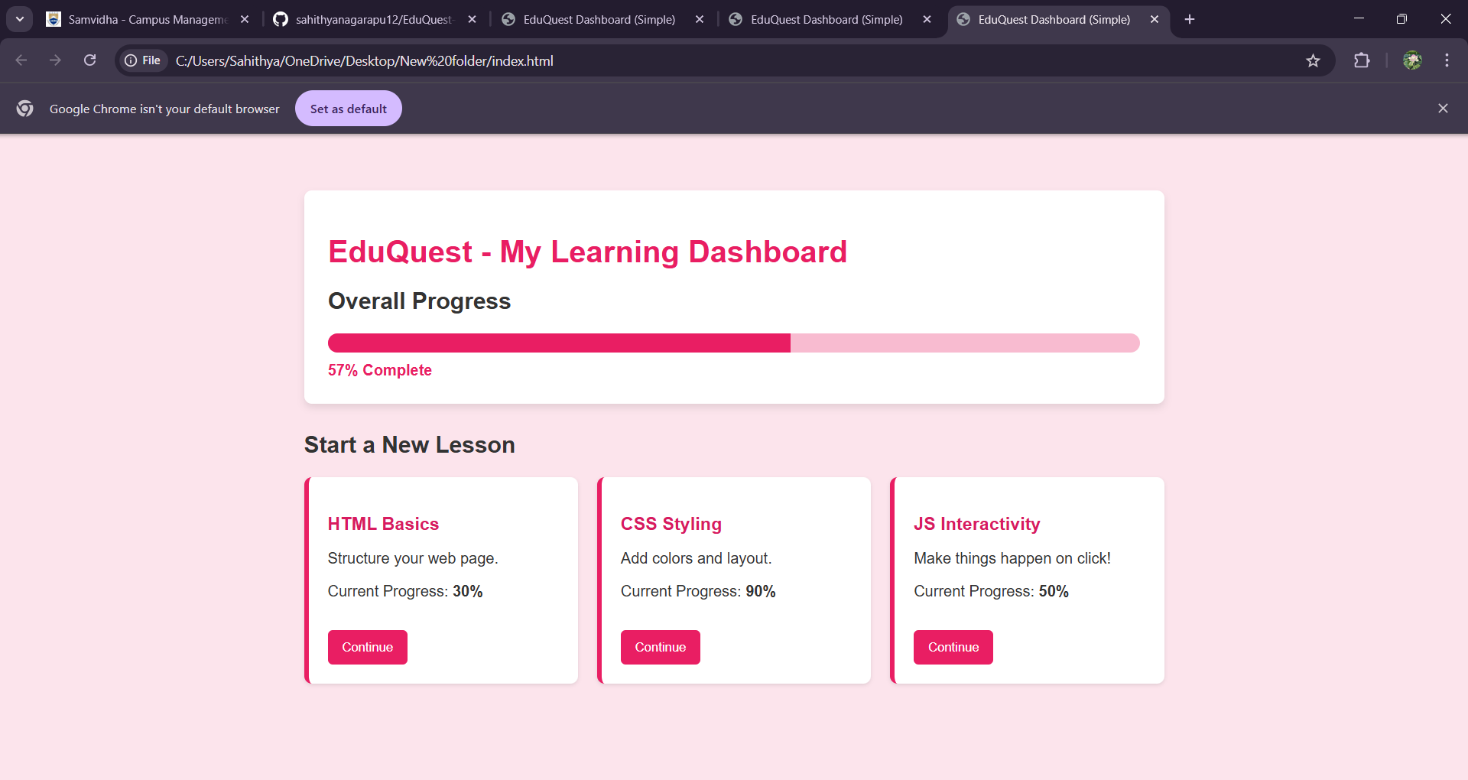
The increase in overall progress as you interact with each topics
